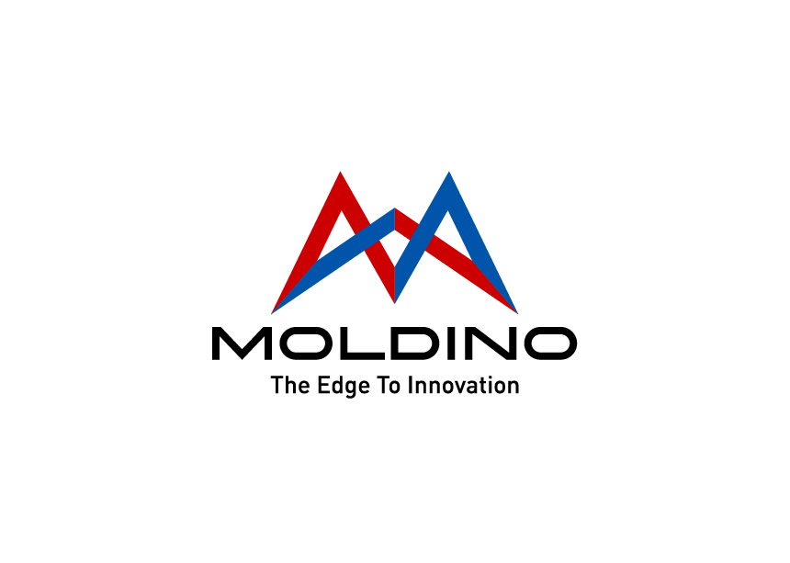

Mr.
Max Mustermann
Musterstr. 157
40721 Hilden
MOLDINO Tool
Engineering Europe GmbH
HR Department
Itterpark 12
40724 Hilden

Place, DD.MM.YYYY

Reimbursement of Travel Expenses
Interview took place on DD.MM.YYYY

Dear Sir or Madam,

Please refer to the table below for the composition of the costs:

Attached please find all original receipts.

Kind regards

Signature

